**Project 1**

<Hangman>

By: Abel Esqueda

Intro to Programming

Date: 07/18/16

**Introduction**

Title: Hangman Game

Hangman is a very simple game. The objective of this game is to guess the word that the other person has chosen. You are given dashes so you know how many letters are in the words or word. If you guess a correct letter that is in the word than the dash will turn into it’s corresponding letter and you will not be penalized. But if you guess a wrong letter than you will be penalized. Every wrong guess a body part is added to the “hangman”. If you guess incorrectly 6 times and you haven’t guessed what the word is than the hangman will have a complete body and you will lose. But if you guess the letters in the words before the hangman is finished than you win.

**Summary**

Project size: about 13000 lines

Number of variables: about 40

Because we hadn’t learned functions up to this point the program has a lot of repeating code with just one variable added to each one. I wanted to try and do a huge loop but was having trouble conceptually. And I tried to stick to only things that we had already learned so I had to break the word into characters and analyze it that way. I initially wanted to make the program accept upper case and lowercase letters but the way I programmed it would not recognize that a lower case letter and an upper case letter are the same because they have different values according to ascII. So I changed the rules and stated that you must use upper case letters. I left that if statement that recognizes lowercase letters because I didn’t want to spend the time to go through all of the code and have to delete all of it.

There were a few debugging issues where I would forget a character or symbol and the program wouldn’t run and I would have to search through and find what I did wrong. I also had logic problems where the code would run but when copying previous lines of code I forgot to change the variable so my code would run but I would have errors or it wouldn’t work right.

**Flowchart**

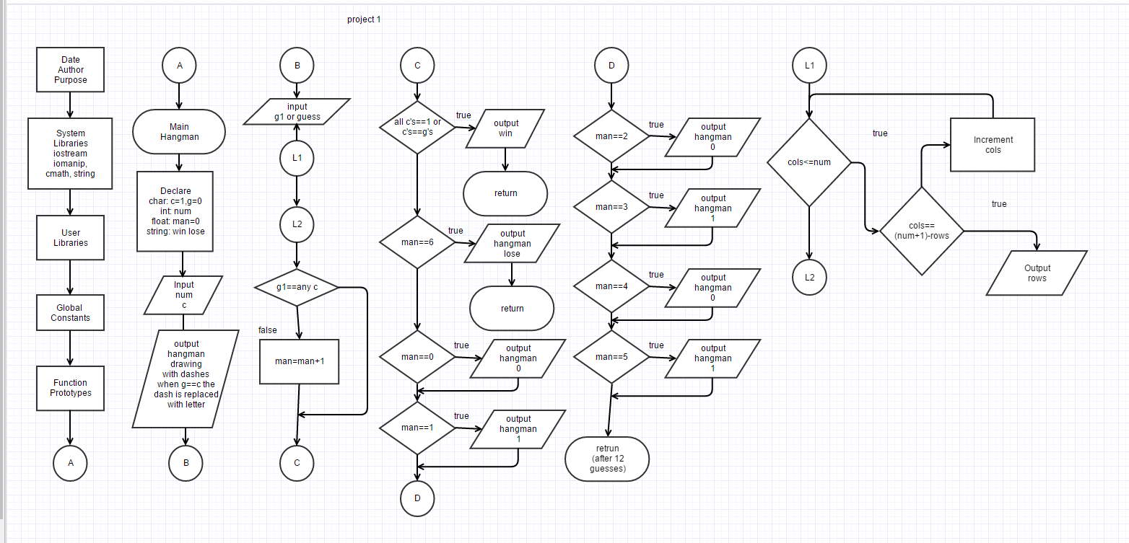

**Major Variables**

|  |  |  |
| --- | --- | --- |
| **Type** | **Variable Name** | **Description** |
| Character | c1 | Character #1 in the word that you put in. |
|  | c2 | Character #2 |
|  | c3 | Character #3 |
|  | c4 | Character #4 |
|  | c5 | Character #5 |
|  | c6 | Character #6 |
|  | c7 | Character #7 |
|  | c8 | Character #8 |
|  | c9 | Character #9 |
|  | c10 | Character #10 |
|  | c11 | Character #11 |
|  | c12 | Character #12 |
|  | c13 | Character #13 |
|  | c14 | Character #14 |
|  | c15 | Character #15 |
|  | c16 | Character #16 |
|  | c17 | Character #17 |
|  | c18 | Character #18 |
|  | c19 | Character #19 |
|  | c20 | Character #20 |
|  | g1 | Guess #1 that you enter to try and guess one of the characters |
|  | g2 | Guess #2 |
|  | g3 | Guess #3 |
|  | g4 | Guess #4 |
|  | g5 | Guess #5 |
|  | g6 | Guess #6 |
|  | g7 | Guess #7 |
|  | g8 | Guess #8 |
|  | g9 | Guess #9 |
|  | g10 | Guess #10 |
|  | g11 | Guess #11 |
|  | g12 | Guess #12 |
| Integer | num | The number of characters in the word that is chosen. |
| Float | Man | a variable that was used to test how many times you entered an incorrect guess. |
| String | Win | A string statement if you win and guess that correct characters |
|  | Lose | A string statement If you lose and aren’t able to guess the correct characters. |
| Integer | i | Used in loop to create a string of * to help make the game more legible. |

**Constructs**

|  |  |  |
| --- | --- | --- |
| **Construct** | **Use** | **Code** |
| If/else | Used for testing bools that I used to determine whether or not the guess was correct. | If (man==0){  Do something…  }else |
| Switch Statement | Used to determine how many characters the program would let you enter based on the number you told it to enter. | Switch (num){  Case 1: ….  Case 2: ….  } |
| cout | Used to output text or variables that were entered or processed | Cout<<”something”<<endl; |
| cin | Used to input values for the variables that were used in this game | Cin>>c1>>c2; |
| For loop | Used to create a line of * three times using a loop to create multiple lines | For(int i=1;i<=3;i++){  Cout<<”***”<<endl;  } |
| If | Similar to if statement but without the else. |  |
| break | The breaks were used in the switch statement to get out of the switch statement once a case is met. | Switch (num){  Case 1: ….;break;  Case 2: ….;break;  } |

Program

I didn’t add the code in here because of how long it ended up. But see the attached code.